Chapter 4, Problem 47.

Obtain the Thevenin and Norton equivalent circuits of the circuit in Fig. 4.114 with respect to terminals a and b.

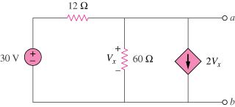

Figure 4.114
For Prob. 4.47.

